**PATROL CAR**

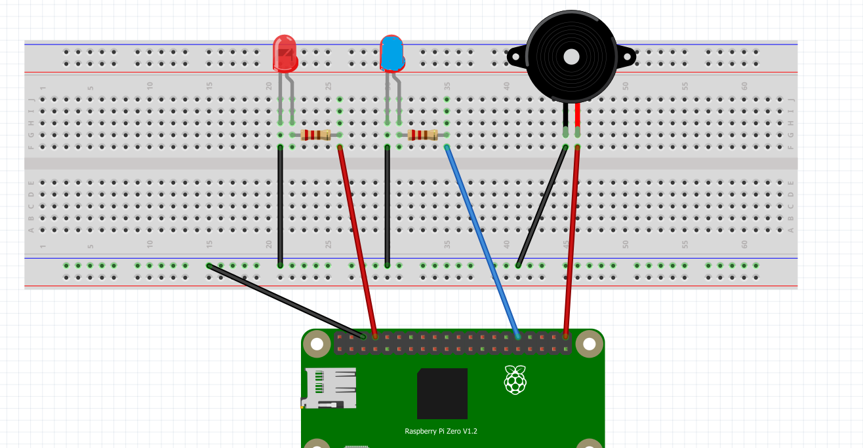

**+**

**GROUND**

**PIN 21**

**PIN 12**

**PIN 14**

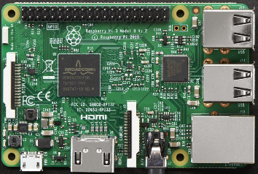

**USB PORTS**